


ཤེས་རིག་དང་རིག་རྩལ་གོང་འཕེལ་ལྷན་ཁག།
ཆུ་མིག་འཕྲུལ་རིག་སྦྱོང་བརྡར་སྤེལ་ཁང་ བུམ་ཐང་།
MINISTRY OF EDUCATION & SKILLs DEVELOPMENT
TECHNICAL TRAINING INSTITUTE-CHUMIG, BUMTHANG

THEORY (BACK PAPER)

Course: Elective Masonry Level: National Diploma
Total marks: 100 Pass Marks: 50
Duration: 3 hrs.

Invigilator’s Initial
CID No:
DIRECTIONS:
- There are FOUR sections of question and you have to answer ALL.
- Write the answers of section A & B in the question paper itself and write the answers of section C & D in answer sheet provided.
- Scrabble answers in Section A won’t be counted.
- Any malpractice during the test shall lead to the direct cancellation of the paper with no marks.

For teacher’s use only
Section | MCQ_A (30) | Other _ B (20) |  |  | SAQ_C (30) | Est._D (20) | Total marks (100)
Marks |  | Q1 (8) | Q2 (6) | Q3 (6)

SECTION A: Multiple Choice Questions
(30 Marks)

Instruction: Circle the best answer from the following statement provided.

- Which of the following side drains is suitable in an urban area where there is moderate rainfall?

  - L shaped drain
  - U shaped drain
  - V shaped drain
  - Trapezoidal shaped drain

- Which of the following is an example of ergonomic hazards?

  - Poor lighting conditions
  - Chemical exposure
  - Repetitive motions
  - Stress
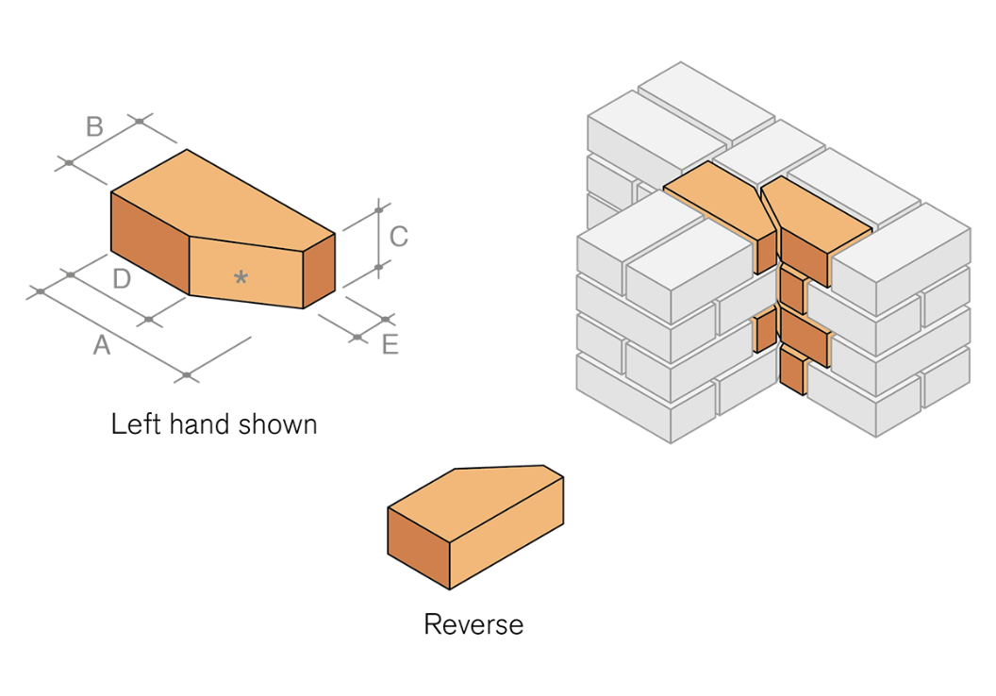
- Identify the type of brick closure shown in the image.

  - King
  - Queen
  - Mitred
  - Beveled

- What will be lapping zone for slab especially in tension zone?

  - Mid, L/1
  - End, L/2
  - Mid, L/3
  - End, L/4

- The minimum clear cover for a RC column is

  - 25 mm.
  - 40 mm.
  - 50 mm.
  - 75 mm.

SECTION B: Other Types Questions
(20 Marks)
Questions 1 (1*8=8 marks)
Instructions: Identify the parts of staircase and write the answer in the space given.
c.
b.
a.
d.
e.
f.
g.
h.

a. ……………………………………
b. ……………………………………
c. ……………………………………
d. ……………………………………
e. ……………………………………
f. ……………………………………
g. ……………………………………
h. ……………………………………

Question 2 (1*6=6 marks)
Instructions: Write True or False in the black space given.
- The function of a geotextile behind a gabion wall is to prevent soil from washing out through the wall. _______________
- Typical bulk density of cement is 1.44 g/cm³. _______________

Question 3 (1*6=6 marks)
Instructions: Fill in the blank with appropriate word(s)
- The positive bending moment usually formed in beam due to stress is termed as __________________________________

SECTION C: Short Answer Questions
(30 marks)

- What is workability of fresh concrete? (1 mark)
- How does implementation of 5S help in daily chores? Explain a few examples. (2 marks)
- Write a difference between one-way slab and two-way slab in terms of the following:
(2 marks)
- Span ratio
- Load transfer

SECTION D: Estimation Type Questions
(20 marks)

- Calculate the weight of main bars in column 6#16Ø of 36 m length? (2 marks)

- Calculate the listed materials given below if the wet volume of M15 concrete grade is 50 ft³. (7 marks)

