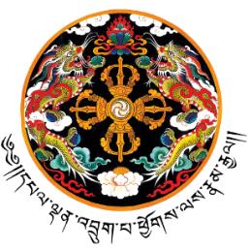

ཆུ་མིག་འཕྲུལ་རིག་སྦྱོང་བརྡར་སྤེལ་ཁང་ བུམ་ཐང་།
ལས་མི་འཆར་གཞི་དང་རིག་རྩལ་གོང་འཕེལ་ལས་ཁུངས།
Technical Training Institute-Chumig, Bumthang
Department of Workforce Planning and Skills Development
Ministry of Education and Skills Development

Statement of Marks

Name:
Citizenship ID card no:
Course:
Course Duration:

Competency Area | Total Marks Obtain | Total (100%) | Remarks
Theory (15%) |  |  | Competent/Not competent
Practical (65%) |  |  | Competent/Not competent
OJT (10%) |  |  | Competent/Not competent
Academic subject (10%) |  |  | Competent/Not competent
Year of graduation |  | 2025 | Competent/Not competent

Issued on: 01/11/2025

Tshering Jamtsho Sangay Tshewang

Note: Attach transcript or learning outcome in back side of statement of marks

